H.T No
Regulations:
A20

Sreenidhi Institute of Science and Technology
(An Autonomous Institution)
Code No:8AC07 Date: 09-Aug-2024 (AN)

B.Tech III-Year II- Semester External Examination, August-2024 (Regular and Supplementary)

LINEAR CONTROL SYSTEMS (ECE)
Time: 3 Hours Max.Marks:70

Note: a) No additional answer sheets will be provided.
b) All sub-parts of a question must be answered at one place only, otherwise it will not be valued.
c) Missing data can be assumed suitably.

Bloom's Cognitive Levels of Learning (BCLL)

Remember | L1 | Apply | L3 | Evaluate | L5
Understand | L2 | Analyze | L4 | Create | L6

Part - A Max.Marks:20
Answer all QUESTIONS

 |  | BCLL | CO(s) | Marks
1 | Write the mason’s gain formula. | L1 | CO1 | [2M]
2 | What are the basic properties of signal flow graph? | L2 | CO2 | [2M]
3 | What is centroid? How the centroid is calculated. | L1 | CO3 | [2M]
4 | What the advantages are of Bode plot. | L1 | CO4 | [2M]
5 | What is nyquist stability criterion? | L1 | CO5 | [2M]
6 | Write the derivation of the transfer function from the state equation. | L2 | CO6 | [2M]
7 | State various time domain specifications of a second order system. | L3 | CO2 | [2M]
8 | What is damping factor and undamped natural frequency? | L1 | CO2 | [2M]
9 | Define the terms state and state variable. | L2 | CO6 | [2M]
10 | Define transfer function and what its limitations are. | L1 | CO1 | [2M]
Part – B Max.Marks:50
ANSWER ANY FIVE QUESTIONS. EACH QUESTION CARRIES 10 MARKS.

 |  |  | BCLL | CO(s) | Marks
11. | a) | Reduce the block diagram and find C/R for shown in figure.  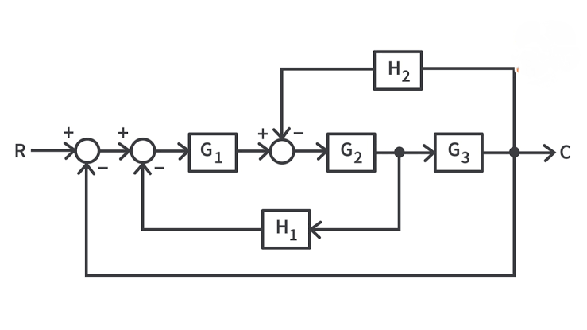 | L5 | CO1 | [5M]
 | b) | Find the overall gain C(s)/R(s) for the signal flow graph.  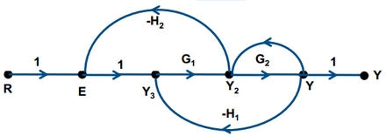 | L5 | CO1 | [5M]
12. | a) | Explain the effects of proportional derivative controller in system performance. | L4 | CO2 | [5M]
 | b) | A second order system is given by C(s)/R(s) =25/s²+6s+25.find its delay time, rise time, peak time, peak overshoot and settling time. | L5 | CO2 | [5M]
13. | a) | Examine the stability by Routh’s criterion.  S⁴+6s³+26s²+56s+80=0. | L5 | CO3 | [5M]
 | b) | For G(s) H(s) = K/s(s+1) (s+4), determine the coordinates of valid breakaway points. | L3 | CO3 | [5M]
14. |  | Sketch the Bode plot for a unity feedback control system with forward path transfer function G(s)=. Determine the gain margin and phase margin. | L4 | CO4 | [10M]
15. | a) | Explain relation between time and frequency response analysis. | L3 | CO5 | [5M]
 | b) | Describe the procedure for developing the polar plot. | L6 | CO5 | [5M]
16. | a) | Diagonalize the system matrix given below.  A = 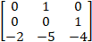 | L5 | CO6 | [5M]
 | b) | Define state Transition matrix and its properties | L5 | CO6 | [5M]
17. | a) | Write the difference between open loop and closed loop control systems. | L2 | CO1 | [5M]
 | b) | Write short notes on Routh Stability Criterion. | L2 | CO3 | [5M]
18. | a) | Define gain margin and phase margin. | L1 | CO4 | [5M]
 | b) | State the advantages and limitations of state variable approach. | L2 | CO6 | [5M]

-- 00 -- 00 –

